PHOENIX
- Tickets:
  - Actors:
    - IEDR API
    - IEDR web-app
    - system PHOENIX
    - Hostmaster – person that validate the tickets
Description:

Ticket – request (registration, modification, deletion) may come from IEDR API or IEDR web-application. Ticket is being created automatically by them. For one domain name it may be only one ticket (Ticket ID is its number, when the ticket change its state, the old state is being save in ticket states history). When all operation will be finished (paperwork etc.) ticket has admin state set to "passed" value. The additional applications make the technical checks. If technical checks are accomplished ticket state become „passed”. When admin and tech states are passed another additional application runs and make changes on domain objects (creation, deletion, modification) then tickets states is being saved in ticket history and the ticket is being deleted by the application.

Scenario:
- Ticket is being created automatically by IEDR API or IEDR web-app.
- Hostmaster searches the ticket by:
- Admin status
- Tech status
- Nic Handles
- Domain name
- (+) domain holder
- Ticket is being check-out by Hostmaster:
- When ticket was check-out by one Hostmaster, other Hostmaster cannot check-out them
- Hostmaster may edit ticket that he hacked out
- Hostmaster may check-out many tickets in same time
- Hostmaster may reassign check-outed ticket by anybody to anybody
- Ticket edition:
- During edition ticket may be accepted or rejected
  - Acceptation
    - (-) Host master has to fill „remark” filed
    - (-) Then Hostmaster should check the ticket in and select “passed” value form the list
    - (+) Acceptation should be done just by clicking accept without filling the „remark” filed and during the check-in of accepted ticket it’s admin state should be automatically set to passed value.
  - Rejection
    - Hostmaster has to fill the remark field (it possible to add a one of standard respones, those tamplates that are being sored in DB).
    - Then Hostmaster should press reject button
    - Then Hostmaster should check-in ticket
    - During the check-in Hostmaster has to select a value form the list e.g. “hold on paperwork”
    - (-) there is possible to get passed or new value from the list but it shouldn’t
    - Rejected ticket is waiting in system till Hostmaster will accept them. It may be rejected many times for different or same reasons.
- During every edition of ticket the e-mail is being sent
        - E-mail’s templates are stored in the DB
        - E-mails are also being sent to IEDR archival account for archiving.
      - If the ticket is „registration ticket” Hostmaster can choose a domain name class and category e.g. for class “ltd. Co. etc” a possible categories are “company name”, “registered trademark” etc. There is a one special class “charity” that makes domain “free” in billing system.
      - GUI:
        - Things that are being changed are marked on red (modification ticket)
        - When nic holder has other domains “domain holder” value its marked red and when hovered other domain names are being shown.
        - In this view is also possible to see if some faxes were send for this domain name
        - (+) link to view the fax message
        - (+) additional info about ticket type (registration, modification, deletion)
        - Field that shows history of the ticket
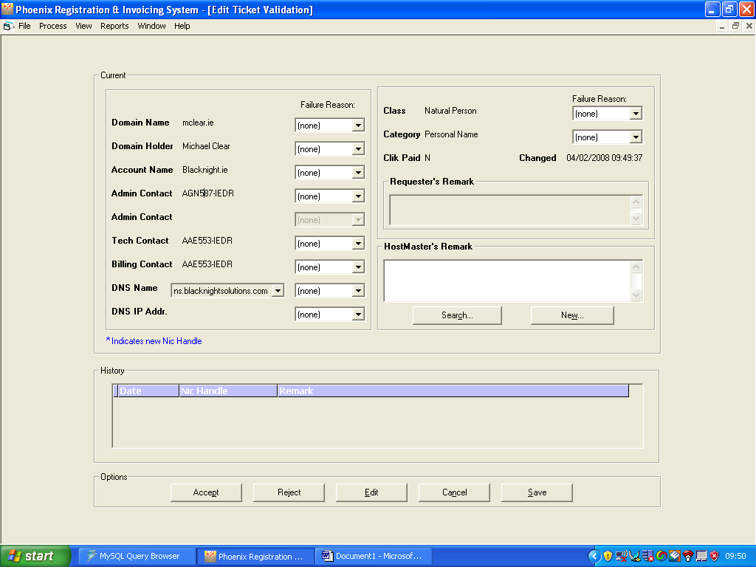
- When ticket has admin status set to passed some technical checks run and when they are accomplished technical status is set to passed value. Then additional application save ticket state in history, make changes on domain object and delete the ticket
- Ticket history
    - View of historical tickets (right now is not working properly.
    - Data are read only.
    - Searching by:
      - Nic Handle
      - Range of dates
      - Ticket type
      - Domain name
      - Etc.

- Additional info
  - about 200 tickets per day are being proceed
  - 2 (sometimes 3) Hostmasters.

